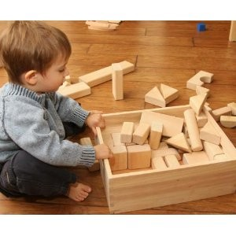

**STAGE 1 (ages 2-3):**  
In this stage, children carry, move, touch, hold, pile, knock down, drop, and feel the blocks. Children do little or no building. Instead, they explore the properties and characteristics of the blocks. Children answer the question, "What can  I do with these?

**Accessories to support learning:**  baskets, buckets, containers, pans boxes, little suitcases, handbags, wagons, big trucks

**Math concepts inherent at this stage:** Attributes (color, size, shape, orientation, texture), measurement/comparison. These concepts will later lead to sorting, which helps us count and compute as we group and re-group sets of objects, make patterns, create balance, find equality, use different units to measure, identify geometric attributes, and organize data.

**Science concepts inherent at this stage:** Properties of matter (The physical properties of blocks differ.)

________________________________________________

[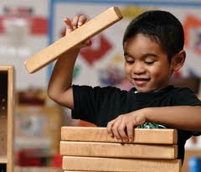](http://blog.mathatplay.org/2012/11/13/block-blog-12-stages-of-block-play/stacking-2/)

**Stage 2 (age 3):**In this stage, children stack blocks vertically, lay them down and line them up, or configure them horizontally. One block may be laid across another. Children will often repeat a pattern over and over. “Stack and row” is a good name for this stage. Many times, you will observe children forming a combination of stacks and rows.

**Accessories to support learning:**vehicles, street signs, trees, a floor mat or boundary marked on the floor, simple block pattern cards

**Math concepts inherent at this stage:**ordering/seriation, equivalent length, ratio of length, sorting, weight, corners/edges/surfaces, one-to-one correspondence

**Science concepts inherent at this stage:**The balance and stability of a structure are influenced by  
1) the placement and position of different-sized and -shaped blocks, and 2) the floor surface. Children are exploring gravity and force.

________________________________________________

[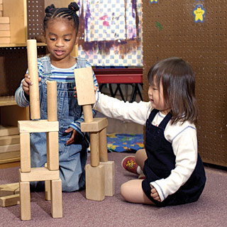](http://blog.mathatplay.org/2012/11/13/block-blog-12-stages-of-block-play/girls-tower/)

**Stage 3 (ages 3-4):**This stage is known as bridging. It is the stage when children begin to make structures. Bridging is when children form a space between two blocks, and then place a block to span the space. Eventually, as the child masters and expands bridging, her bridges become more elaborate. Typically the child will build in the stacks and rows she previously made and add the bridges.

**Accessories to support learning:**boats, blue cloth (water), photos and drawings of bridges, cake columns (used to hold up wedding cakes), paper towel rolls, sturdy lengths of cardboard

**Math concepts inherent at this stage:**Spatial concepts(e.g., positional words, relationships, maps/directions),Geometry concepts(e.g., recognizing and naming shapes, transformation)

**Science concepts inherent at this stage:**compression and tension

_________________________________________________

[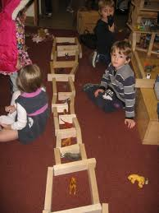](http://blog.mathatplay.org/2012/11/13/block-blog-12-stages-of-block-play/fence-wall-2/)

**Stage 4 (age 4):**This stage involves making enclosures. At this stage, children can close up a space between blocks with another block(s). Children begin problem solving by planning ahead how they will close up spaces. After mastering enclosures by lying the blocks flat on the floor, children make an enclosure by standing the blocks on edge, and they may incorporate bridging. Children add figures, which take on imaginary roles as children play out social motifs that are meaningful to them.

**Accessories to support learning:**photos of enclosures, animals, fruits and vegetables, plates and bowls, lengths of ribbon, yarn or rope, dollhouse furniture and dolls

**Math and Science concepts inherent at this stage:**Architectural features (e.g., interior and exterior space, perimeter, measurement, number of openings, numeral awareness/recognition, number relationships, problem solving/computation, Parts-to-whole relationships)

**___________________________________________**

[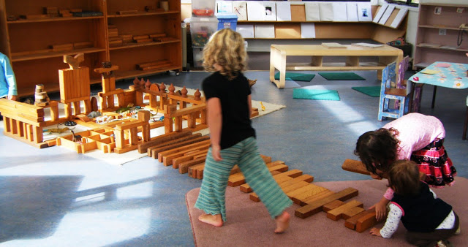](http://blog.mathatplay.org/2012/11/13/block-blog-12-stages-of-block-play/5-may-007/)                                  (www.progressiveearlychildhoodeducation.blogspot.com)

**Stage 5 (ages 4-5):**This is the stage where children begin making elaborate, decorative structures. For example, the child may incorporate a bathtub, store, farmyard and swing into the same structure. Often, children name their structures (although the names rarely define the structure’s function). Patterns emerge in children’s structures, and symmetry is more intricate.

**Accessories to support learning:**large photos of structures, books about building, tall boxes (skyscrapers), paper, blank books, clipboards, writing tools, scissors, tape, task cards, fabric, tiles, palm leaves, carpet squares, large pieces of cardboard, shingles, small rugs or blankets, mirrors, tools, tape measures, dress-up clothes, pulley, small branches, tree cookies, small embellishments (aka loose parts, e.g., 1" color cubes, counters, shells, pebbles, seed pods, pinecones)

**Math concepts inherent at this stage:**Patterns, symmetry, equality, classification

**Science and Social Studies concepts inherent at this stage:**1) Structures vary in function,  
2) Physical geography defines the use of land surface in a community,  
3) Observations, books, tools and technology can help with investigations.

________________________________________________

[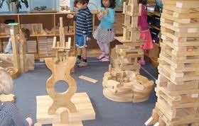](http://blog.mathatplay.org/2012/11/13/block-blog-12-stages-of-block-play/elaborate/)

**Stage 6 (ages 5-6+):**At this stage, children work cooperatively to build a structure, deciding in advance what they will build. They build their structures to look much like what they have planned in advance. Due to the complexity of the structure and the commitment of the children, they typically want to build and play with the structure over a period of several days. While building, the children assign each other roles, and they use a variety of materials to achieve the desired effects. They will also begin dramatic play around the block structure.

________________________________________________

Source for descriptions of each stage (in blue): MacDonald, Sharon, Block Play: The Complete Guide to Learning and Playing with Blocks,Gryphon House, 2001

References: Copeland, Sherry M. and Schwartz, Sydney L., Connecting Emergent Curriculum and Standards in the Early Childhood Classroom: Strengthening Content and Teaching Practice, Teachers College Press, 2010

www.progressiveearlychildhoodeducation.blogspot.com